 |  | 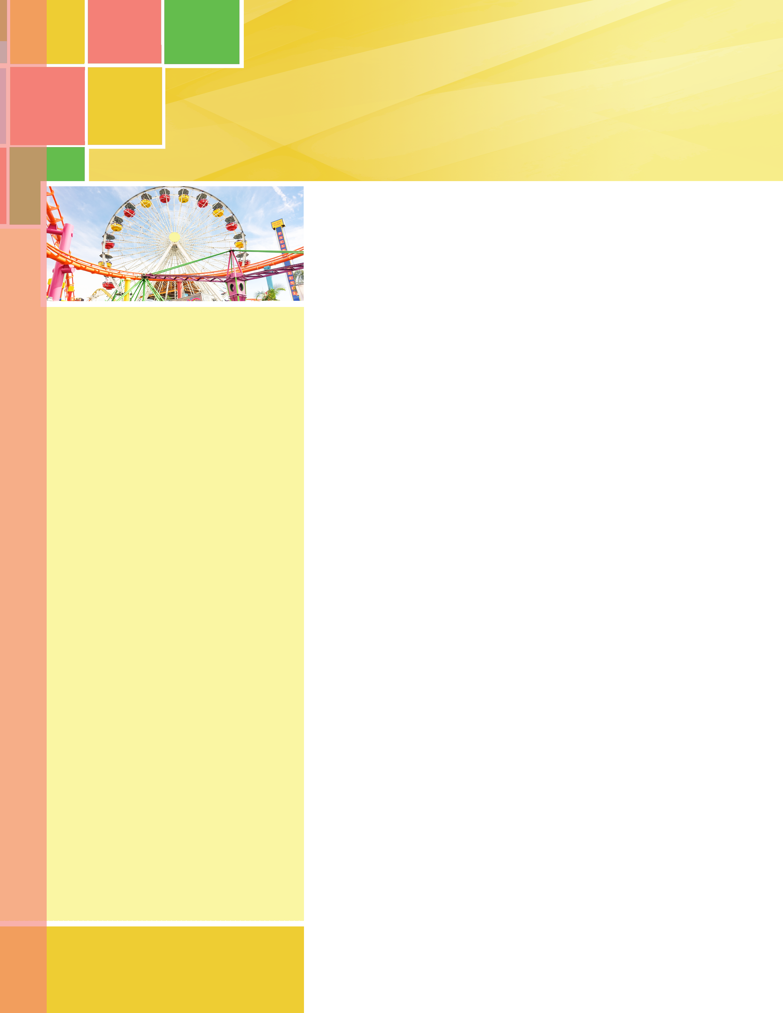 | New Haven Times
Your Mailing Address  Street Number and Name  City, State ZIP Code  Postage Information  Your Return Address  Street Number and Name  City, State ZIP Code |  | August Birthdays  Happy Birthday to:  Dolores Smith August 11  Mary Rodriguez August 30  Word Puzzle  How many words can you find in  ROTAVATOR  Meaning: A type of soil tiller, the longest non- coined palindromic word included in an English dictionary tallies nine letters.
 |  |  | New Haven Assisted Living and Memory Care * 21331 Falvel Rd. Spring Texas 77388 * Ph# 832-850-5317
August Features

August 16- Memory Matters Support Group
7pm in the assisted living dayroom

August 18- Live Music with Blaine Faul
2:30 in assisted living

August 24- Sports Talk with Marcus Hudson from the San Francisco 49ers
7pm

August 30- Family Night sponsored by United Health Care and Kindred House Calls

New Haven would like to welcome our newest residents: David Daniels and Isabell Childers



In astrology, those born between August 1–22 are Lions of Leo. Leos are natural-born leaders: confident, charismatic, and creative. Leos also use their humor and loyalty to bring people together. Those born between August 23–31 are Virgo Virgins. Virgos are one of the most careful signs of the zodiac. They pay attention to detail, analyze problems, and plan so as to leave nothing to chance. These amazing listeners give excellent advice.

AUGUST 2018

August 2018

